**Lab Report 9**

**Digital Image Processing**

**CSE438**

**Section:** 03

**Semester:** Spring-2025

**Submitted To:**

**Md. Asif Khan Rifat**

**Lecturer**

Department of Computer Science

and Engineering

**Submitted By:**

                                                                         Suddip Paul Arnab

**2022-1-60-356**

**Date of submission:** 22 May 2025

**Final Lab-09 (Assignment)**

1. Segment the tumor from Figure 1 by using:

i. Region growing approach

**Code**:

img = imread('Picture1.png');

gray_img = im2gray(img);

gray_img = double(gray_img);

gray_img = imgaussfilt(gray_img, 1);

gray_img = (gray_img - min(gray_img(:))) / (max(gray_img(:)) - min(gray_img(:)));

[M, N] = size(gray_img);

figure('Name', 'Select Tumor Seed Point', 'NumberTitle', 'off');

imshow(gray_img, []);

title('Click on the tumor to select a seed point, then press Enter');

[seed_y, seed_x] = ginput(1);

seed_x = round(seed_x(1));

seed_y = round(seed_y(1));

close(gcf);

seed_intensity = gray_img(seed_y, seed_x);

threshold = 0.2;

bw = false(M, N);

bw(seed_y, seed_x) = true;

stack = [seed_y, seed_x];

neighbors = [-1, -1; -1, 0; -1, 1; 0, -1; 0, 1; 1, -1; 1, 0; 1, 1];

while ~isempty(stack)

current = stack(end, :);

stack(end, :) = [];

y = current(1);

x = current(2);

for k = 1:size(neighbors, 1)

ny = y + neighbors(k, 1);

nx = x + neighbors(k, 2);

if ny >= 1 && ny <= M && nx >= 1 && nx <= N && ~bw(ny, nx)

if abs(gray_img(ny, nx) - seed_intensity) <= threshold

bw(ny, nx) = true;

stack = [stack; ny, nx];

end

end

end

end

se = strel('disk', 2);

bw = imopen(bw, se);

bw = imclose(bw, se);

bw = bwareaopen(bw, 30);

tumor_outline = bwperim(bw);

overlay = imoverlay(gray_img * 255, tumor_outline, [1 0 0]);

figure('Name', 'Tumor Segmentation Using Region Growing', 'NumberTitle', 'off');

subplot(1, 2, 1), imshow(img), title('Original Image');

subplot(1, 2, 2), imshow(bw), title('Tumor Mask');

disp('Tumor segmentation using Region Growing complete!');

**Output**:

ii. Region Splitting and Merging approach

**Code**:

img = imread('Picture1.png');

gray_img = im2gray(img);

gray_img = double(gray_img);

gray_img = imgaussfilt(gray_img, 1);

gray_img = (gray_img - min(gray_img(:))) / (max(gray_img(:)) - min(gray_img(:)));

[M, N] = size(gray_img);

min_region_size = 8;

split_threshold = 0.1;

function should_split = needSplit(img_region, threshold)

if isempty(img_region)

should_split = false;

return;

end

region_std = std(img_region(:));

should_split = region_std > threshold;

end

regions = {[1, 1, M, N]};

homogeneous_regions = {};

while ~isempty(regions)

current_region = regions{1};

regions(1) = [];

r_start = current_region(1);

c_start = current_region(2);

height = current_region(3);

width = current_region(4);

img_region = gray_img(r_start:r_start+height-1, c_start:c_start+width-1);

if height <= min_region_size || width <= min_region_size || ~needSplit(img_region, split_threshold)

homogeneous_regions{end+1} = current_region;

else

h_half = floor(height/2);

w_half = floor(width/2);

regions{end+1} = [r_start, c_start, h_half, w_half];

regions{end+1} = [r_start, c_start+w_half, h_half, width-w_half];

regions{end+1} = [r_start+h_half, c_start, height-h_half, w_half];

regions{end+1} = [r_start+h_half, c_start+w_half, height-h_half, width-w_half];

end

end

region_intensities = zeros(length(homogeneous_regions), 1);

for i = 1:length(homogeneous_regions)

region = homogeneous_regions{i};

r_start = region(1);

c_start = region(2);

height = region(3);

width = region(4);

img_region = gray_img(r_start:r_start+height-1, c_start:c_start+width-1);

region_intensities(i) = mean(img_region(:));

end

figure('Name', 'Select Tumor Seed Point', 'NumberTitle', 'off');

imshow(gray_img, []);

title('Click on the tumor to select a seed point, then press Enter');

[seed_y, seed_x] = ginput(1);

seed_x = round(seed_x);

seed_y = round(seed_y);

close(gcf);

seed_region_idx = -1;

for i = 1:length(homogeneous_regions)

region = homogeneous_regions{i};

r_start = region(1);

c_start = region(2);

height = region(3);

width = region(4);

if seed_y >= r_start && seed_y < r_start+height && ...

seed_x >= c_start && seed_x < c_start+width

seed_region_idx = i;

break;

end

end

seed_intensity = region_intensities(seed_region_idx);

merge_threshold = 0.15;

tumor_mask = false(M, N);

for i = 1:length(homogeneous_regions)

region = homogeneous_regions{i};

r_start = region(1);

c_start = region(2);

height = region(3);

width = region(4);

if abs(region_intensities(i) - seed_intensity) <= merge_threshold

tumor_mask(r_start:r_start+height-1, c_start:c_start+width-1) = true;

end

end

se = strel('disk', 2);

tumor_mask = imopen(tumor_mask, se);

tumor_mask = imclose(tumor_mask, se);

tumor_mask = bwareaopen(tumor_mask, 50);

CC = bwconncomp(tumor_mask);

pixelIdxList = CC.PixelIdxList;

seed_idx = sub2ind(size(tumor_mask), seed_y, seed_x);

component_with_seed = -1;

for i = 1:CC.NumObjects

if any(pixelIdxList{i} == seed_idx)

component_with_seed = i;

break;

end

end

final_mask = false(M, N);

if component_with_seed > 0

final_mask(pixelIdxList{component_with_seed}) = true;

else

num_pixels = cellfun(@numel, pixelIdxList);

[~, largest_idx] = max(num_pixels);

final_mask(pixelIdxList{largest_idx}) = true;

end

tumor_outline = bwperim(final_mask);

rgb_img = repmat(gray_img, [1, 1, 3]);

overlay = rgb_img;

overlay(:,:,1) = overlay(:,:,1) + tumor_outline * 0.7;

overlay(:,:,2) = overlay(:,:,2) - tumor_outline * 0.3;

overlay(:,:,3) = overlay(:,:,3) - tumor_outline * 0.3;

overlay = min(max(overlay, 0), 1);

figure('Name', 'Tumor Segmentation Using Region Splitting and Merging', 'NumberTitle', 'off');

subplot(2, 2, 1), imshow(img), title('Original Image');

subplot(2, 2, 2), imshow(gray_img, []), title('Preprocessed Image');

subplot(2, 2, 3), imshow(final_mask), title('Tumor Mask');

subplot(2, 2, 4), imshow(overlay), title('Tumor Outline');

disp('Tumor segmentation using Region Splitting and Merging complete!');

**Output**:

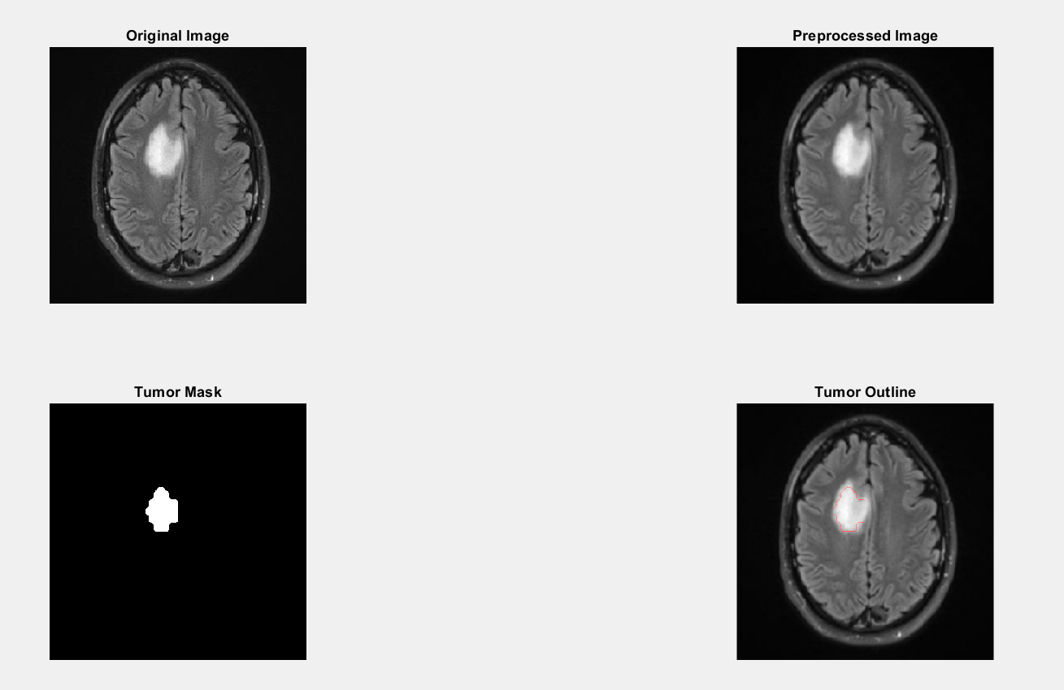

1. Segment the tumor from Figure 1 by using Marker Controlled Watershed segmentation.

**Code**:

img = imread('Picture1.png');

gray = rgb2gray(img);

gray_filtered = medfilt2(gray, [3 3]);

gray_eq = adapthisteq(gray_filtered);

gmag = imgradient(gray_eq);

se = strel('disk', 3);

Io = imopen(gray_eq, se);

Ie = imerode(gray_eq, se);

Iobr = imreconstruct(Ie, gray_eq);

Iobrd = imdilate(Iobr, se);

Iobrcbr = imreconstruct(imcomplement(Iobrd), imcomplement(Iobr));

Iobrcbr = imcomplement(Iobrcbr);

fgm = imregionalmax(Iobrcbr);

bw = imbinarize(Iobrcbr);

D = bwdist(~bw);

DL = watershed(D);

bgm = DL == 0;

gmag2 = imimposemin(gmag, bgm | fgm);

L = watershed(gmag2);

tumorMask = L == 0;

figure('Name', 'Marker-Controlled Watershed Tumor Segmentation');

subplot(1, 3, 1);

imshow(gray); title('Original MRI');

subplot(1, 3, 2);

imshow(gmag, []); title('Gradient Magnitude');

subplot(1, 3, 3);

imshow(gray); hold on;

h = imshow(tumorMask);

set(h, 'AlphaData', 0.5);

title('Watershed Tumor Segmentation');

**Output**:

1. Segment the tumor from Figure 1 by using Quadtree Segmentation.

**Code**:

img = imread('Picture1.png');

gray = rgb2gray(img);

gray = medfilt2(gray, [3 3]);

gray_resized = imresize(gray, [512 512]);

threshold_std = 15;

predicate = @(block) std2(block) > threshold_std;

S = qtdecomp(gray_resized, predicate);

mask = zeros(size(gray_resized));

block_sizes = [512 256 128 64 32 16 8 4];

for k = 1:length(block_sizes)

bsize = block_sizes(k);

[vals_x, vals_y] = find(S == bsize);

for i = 1:length(vals_x)

x = vals_x(i); y = vals_y(i);

if x + bsize - 1 <= size(gray_resized,1) && y + bsize - 1 <= size(gray_resized,2)

block = gray_resized(x:x+bsize-1, y:y+bsize-1);

if mean(block(:)) > 100

mask(x:x+bsize-1, y:y+bsize-1) = 1;

end

end

end

end

mask = bwareaopen(mask, 50);

mask = imfill(mask, 'holes');

mask = imclose(mask, strel('disk', 3));

mask = imerode(mask, strel('disk', 1));

mask_resized = imresize(mask, size(gray), 'nearest');

figure('Name', 'Quadtree Tumor Segmentation');

subplot(1, 2, 1);

imshow(gray); title('Original MRI Image');

subplot(1, 2, 2);

imshow(gray); hold on;

redMask = cat(3, ones(size(gray)), zeros(size(gray)), zeros(size(gray)));

h = imshow(redMask);

set(h, 'AlphaData', double(mask_resized) * 0.4);

boundaries = bwboundaries(mask_resized);

for k = 1:length(boundaries)

boundary = boundaries{k};

plot(boundary(:,2), boundary(:,1), 'g', 'LineWidth', 1.5);

end

title('Tumor Segmentation using Quadtree');

**Output**:

